
Maize Analytics

Troubleshooting if EBAS is not loading
Sometimes your Maize tool may have trouble loading after an update. A way to troubleshoot this yourself is by doing a hard refresh. A hard refresh is a way of clearing the browser’s cache for a specific page, to force it to load the most recent version of a page. Sometimes, when changes are made to the website, they don’t register immediately due to caching. A hard refresh will usually fix this, though occasionally completely clearing the cache is necessary.

We suggest you use Chrome Browser for the best experience of the Maize tool. To hard refresh in Chrome please complete the following steps:

Open the Developer tools by clicking the vertical ellipses in the top right corner of Chrome's menu bar --- > then choose “More Tools” > then Developer Tools. When you click developer tools, it will load the developer tools
in the right of the screen, you do not have to make any changes within that. Once you are in the Developer Tools setting, put your mouse cursor over the refresh button on your toolbar and hold down. When you hold down you will see several refresh options, click “Empty Cache and Hard Reload”. This will hard reload the page, you can then hit the "x" on the developer tools and resume your workflow.

This may help some features load in the EBAS tool that may not have been previously loading due to an EBAS error.

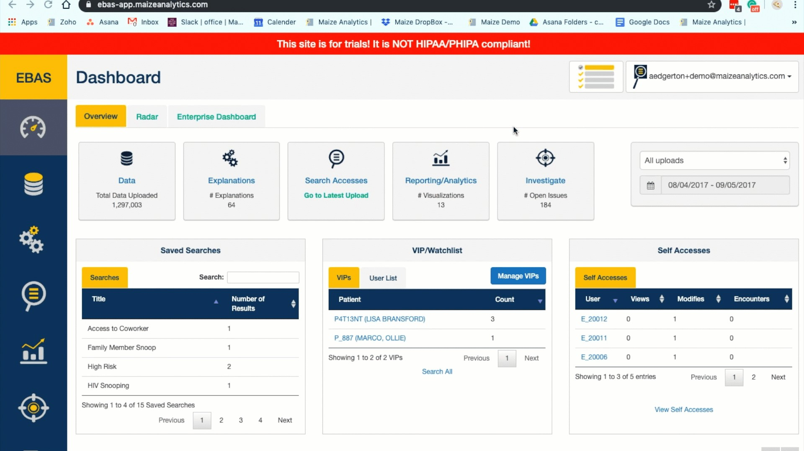

If you use Internet Explorer: Follow along with the instructions/pictures on this site: http://refreshyourcache.com/en/internet-explorer-11
Note that while the instructions tell you to to to the "Delete Browsing History" section of your IE Settings, if you prefer to preserve your browser history, just make sure to only check "Temporary Internet Files and Website Files" before clicking delete.

